**System Integration Final Project Documentation**

**Name:** Pranay Katakam

**API NAME:** Microsft Azure Translator API

Microsoft Azure Documentation can be found [here](https://docs.microsoft.com/en-in/azure/cognitive-services/translator/).

My project contains two API’s,

**1)Languages API-**

* It is a simple get API, designed to retrieve all the languages available to translate in azure translator.
* The response is a JSON of JSON objects, with the key being the language code value being language information.
* This key is used in the next translate API for translating from one to one or one to many languages.
* Swagger URL ->[**http://143.244.161.246:3000/docs/#/Translate/get_languages**](http://143.244.161.246:3000/docs/#/Translate/get_languages)
* Swagger screenshot -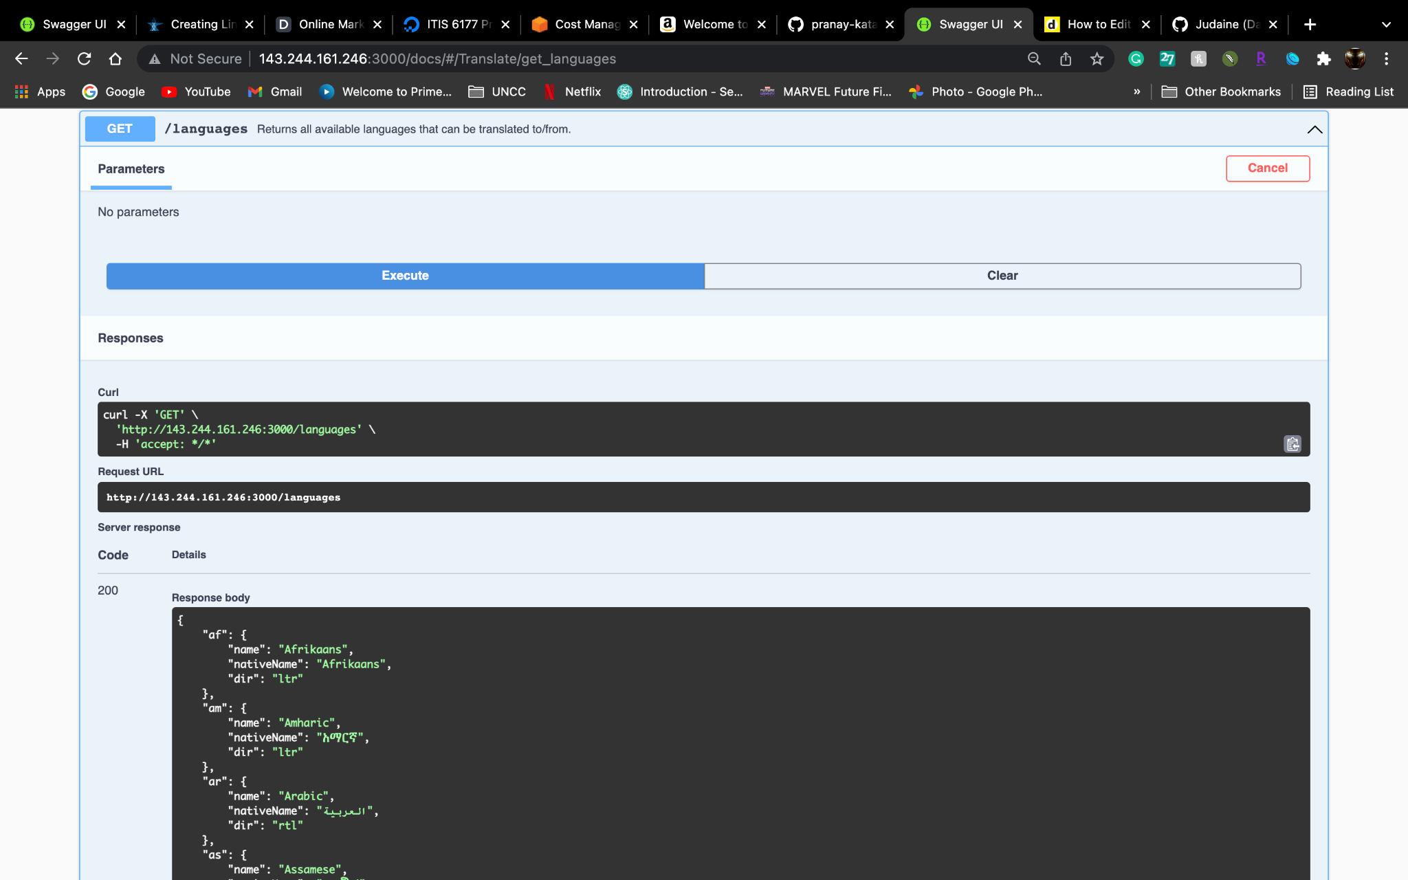

**2) Translate API**

* It is post API, used for translating one language code into one or many languages
* Request Body -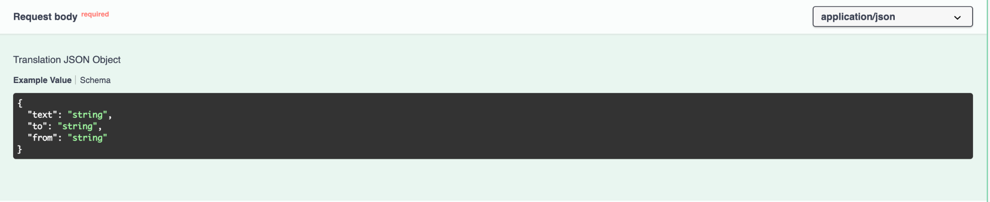
* In the above request body, **from** attribute is optional. If “from” key is missing translator API automatically detects the incoming language and translates it to the desired language.
* Text attribute is the text which needs to be translated
* To attribute can either be a single language-code type-string, for example, “en” or a list of string values for example, [“en”,”as”].
* Example Request Body -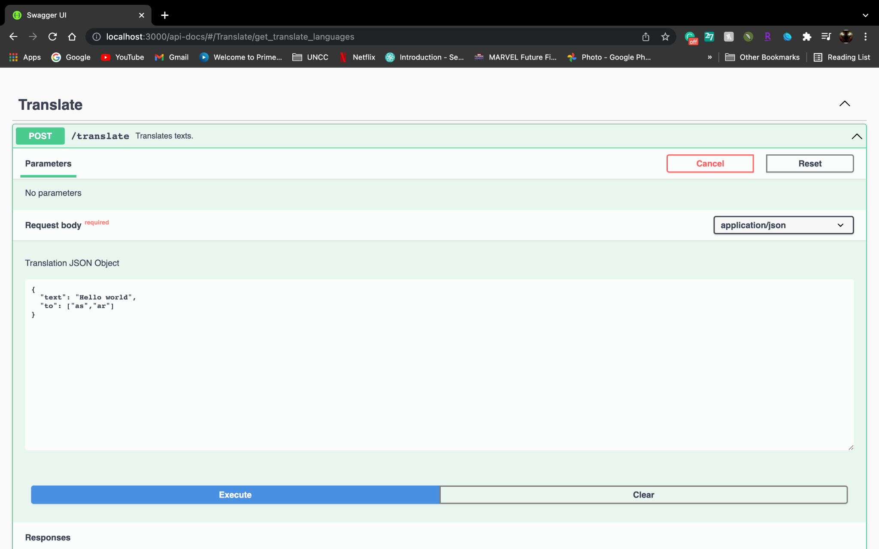
* Response -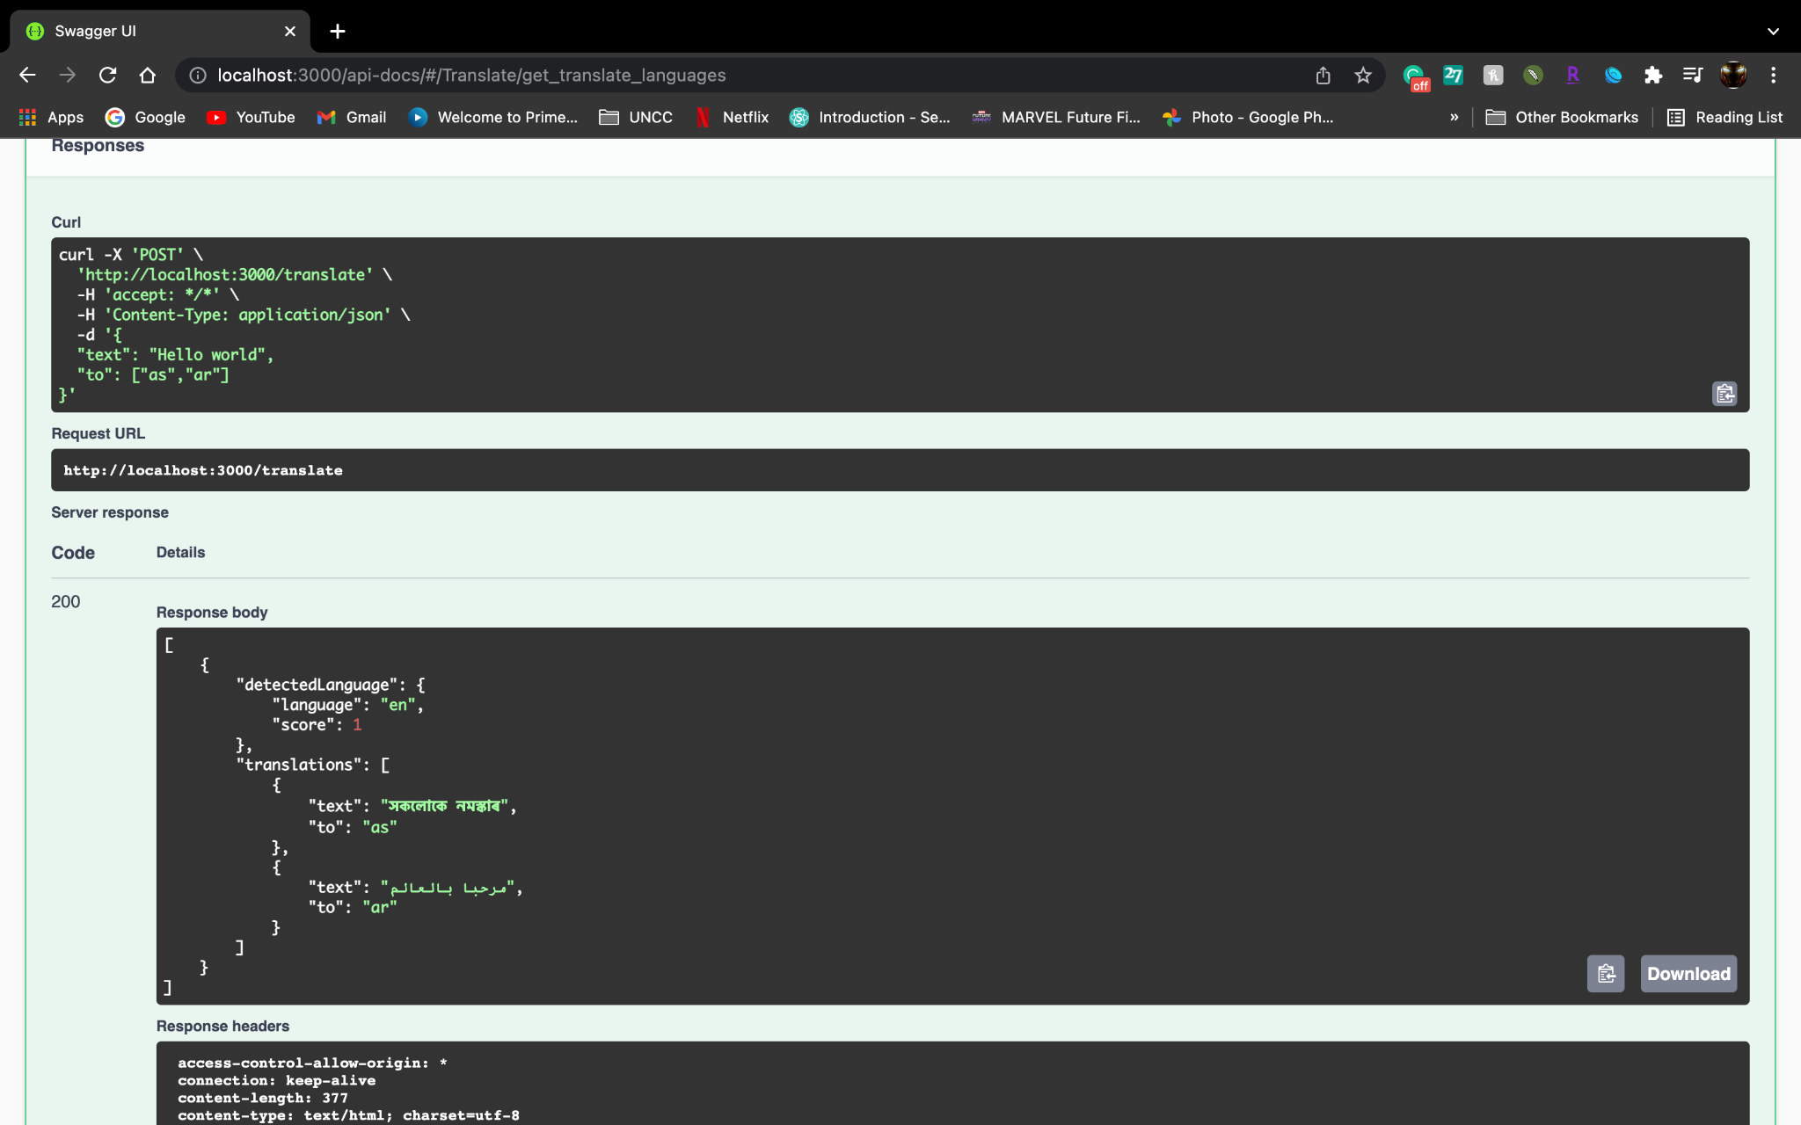
* In the above example from language is not specified, so the azure translator API automatically translated the text to the specified languages and in response added the detected language.
* Example with from attribute -
  + Request -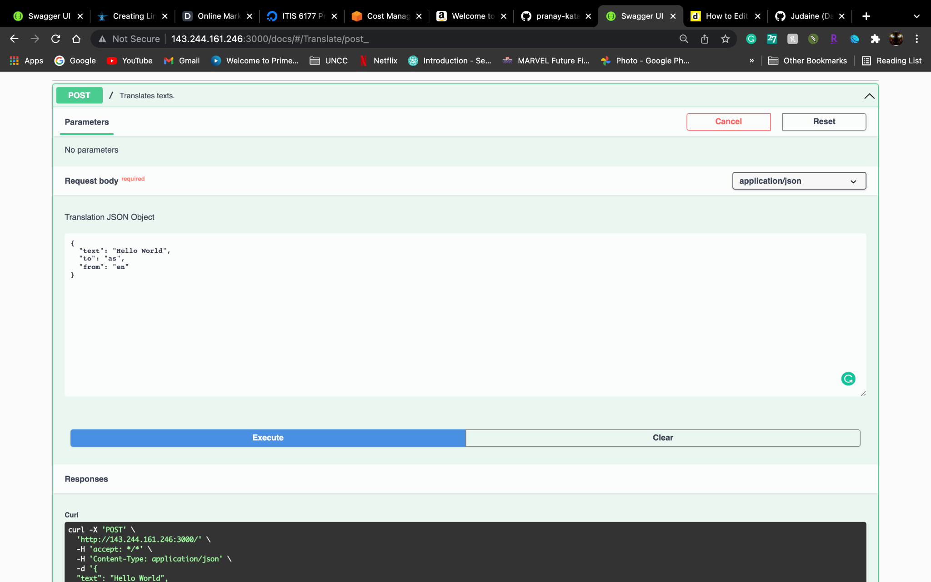
  + Response -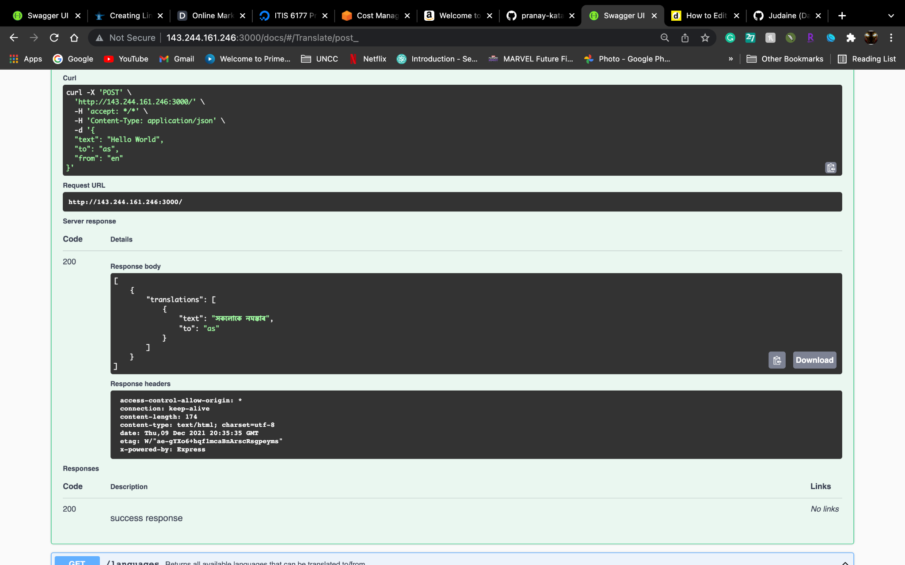
* Swagger URL -<http://143.244.161.246:3000/docs/#/Translate/post_>

Swagger is provided for documentation and for testing API’s.

Swagger link - <http://143.244.161.246:3000/docs/>

**Tools, Languages and Frameworks Used-**

* **Node js** - For implementing the API
* **Digital Ocean** - For deploying the project
* **Npm** - For dependencies in node js application
* **Swagger** - For API documentation and testing
* **Git** - For code evaluation
* **Google docs** - For documentation.

**References -**

**Azure documentation -**

[**https://docs.microsoft.com/en-in/azure/cognitive-services/translator/**](https://docs.microsoft.com/en-in/azure/cognitive-services/translator/)

**Source Code -** [**https://github.com/pranay-katakam/Pranay-ITIS-6177-Final-Project-Azure-Translate-API**](https://github.com/pranay-katakam/Pranay-ITIS-6177-Final-Project-Azure-Translate-API)